2/8/2022

Pinni Venkata Abhiram

20BAI1132

CSE3004 – Internet and Web Programming

Lab – 6

Questions

1. Create 3 options to display the course codes of winter 21-22. When the student clicks the options the corresponding course slot names to be displayed. Provide the facility for the student to select more than one course option for this scenario.
2. Write the required CSS code to change the color of the text from black to red when the mouse moves over the text
3. Write a CSS code for displaying your name infinitely in the web page in alternate text color with two different size of the fonts. Ensure the animation runs infinitely.

HTML Code

<!DOCTYPE html>

<html lang="en">

<head>

    <meta charset="UTF-8">

    <meta http-equiv="X-UA-Compatible" content="IE=edge">

    <meta name="viewport" content="width=device-width, initial-scale=1.0">

    <title>Animations</title>

    <link rel="stylesheet" href="styles.css">

</head>

<body style="border: 1px solid; margin: 40px;">

    <h1 style="margin-left: 40px;" class="animation">PV Abhiram</h1>

    <h2 style="margin-top: 40px; text-align: center;" class="jo"> Hover Example </h2>

    <div style="padding-left: 40px; margin-top: 40px;">

        <input type="checkbox" name="course" value="IWP" onclick="function1(); function2();"> IWP <br>

        <div class="ans1 font"></div><br><br>

        <input type="checkbox" name="course" value="DAA" onclick="function1(); function2();"> DAA <br>

        <div class="ans2 font"></div><br><br>

        <input type="checkbox" name="course" value="ALA" onclick="function1(); function2();"> ALA <br>

        <div class="ans3 font"></div><br><br>

    </div>

    <br><br><br>

</body>

<script src="index.js"></script>

</html>

CSS Code

.animation

{

    text-align: center;

    animation-name: example;

    animation-duration: 4s;

    animation-iteration-count: infinite;

    direction:rtl;

}

.jo:hover

{

    color: aqua;

    font-size: 40px;

}

@keyframes example {

    from {color: red; font-size: 30px;}

    to {color: blue; font-size: 60px;}

  }

JS Code

function function1()

{

    var x = document.getElementsByName("course");

    for (var i = 0 ; i < x.length ; i++)

    {

        document.querySelectorAll(".font")[i].style.fontFamily = "Verdana,bold,arial";

        document.querySelectorAll(".font")[i].style.fontWeight = "900";

        if (x[i].checked == true)

        {

            var ans = (x[i].value).toUpperCase();

            if (ans == "IWP")

            {

                document.querySelector('.ans1').innerHTML = ans + " is selected and the code is CSE3002 and F1 slot";

            }

            if (ans == "DAA")

            {

                document.querySelector('.ans2').innerHTML = ans + " is selected and the code is CSE2012 and D1 slot";

            }

            if (ans == "ALA")

            {

                document.querySelector('.ans3').innerHTML = ans + " is selected and the code is MAT3004 and A1 slot";

            }

        }

    }

}

Output

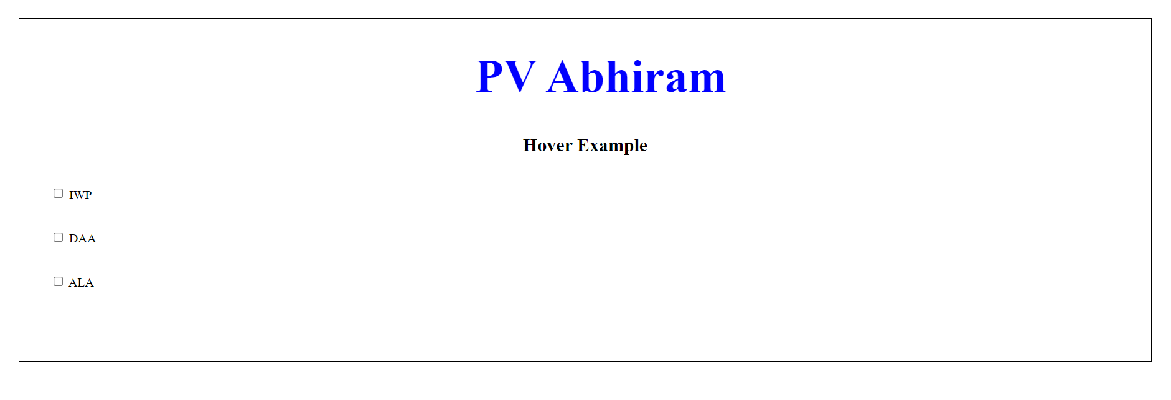

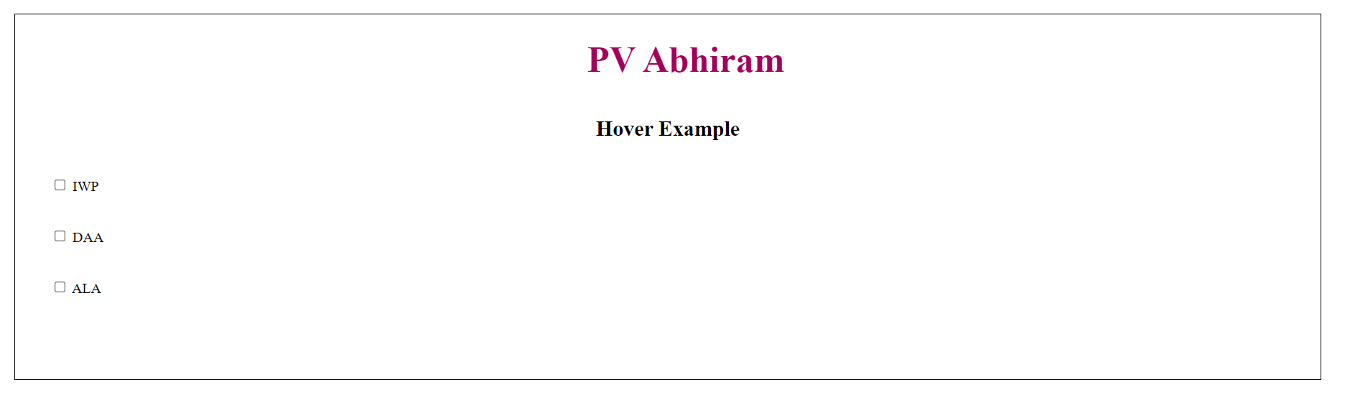

Animations of name heading





Hover Example

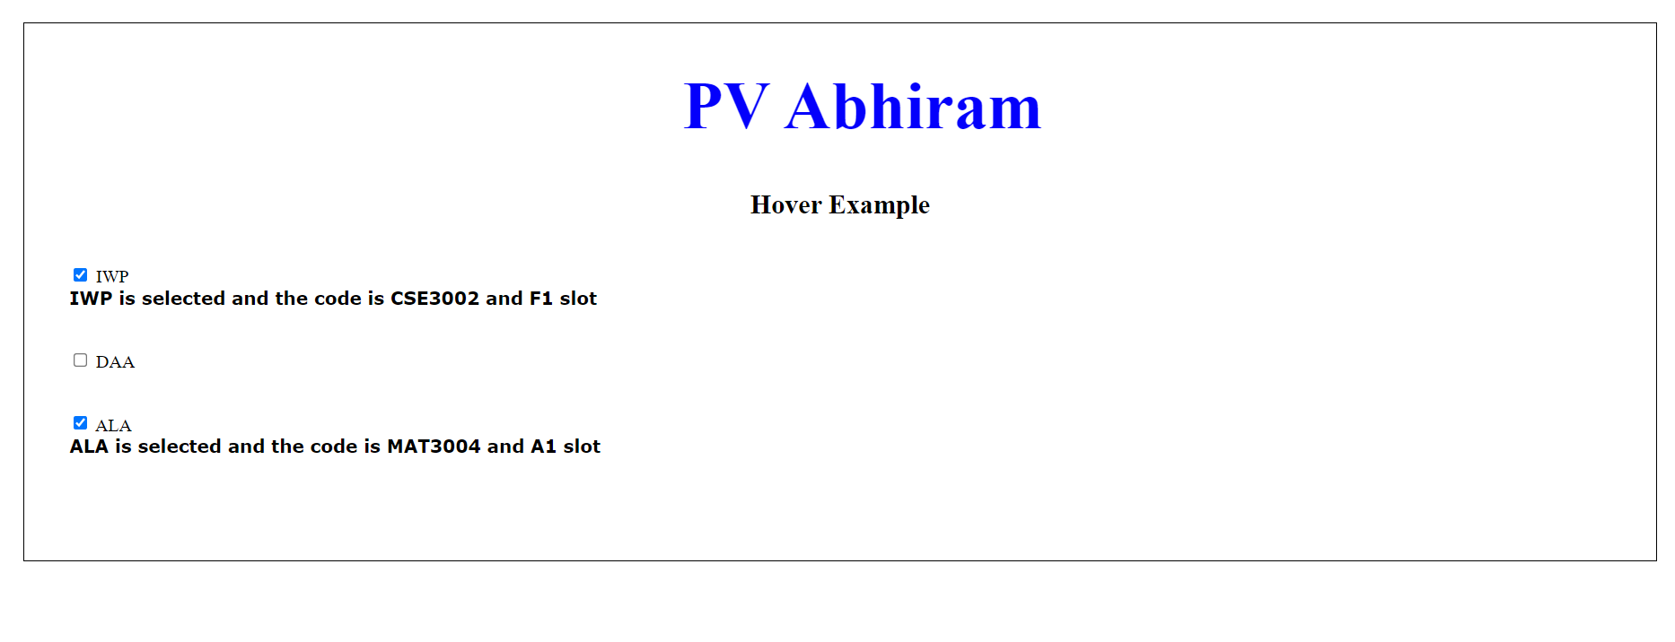

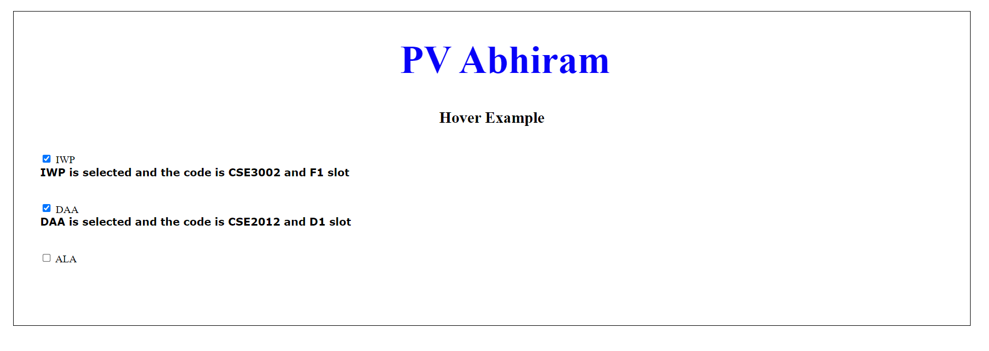

Checkbox

Thank you ma’am

Pinni Venkata Abhiram

20BAI1132